Book

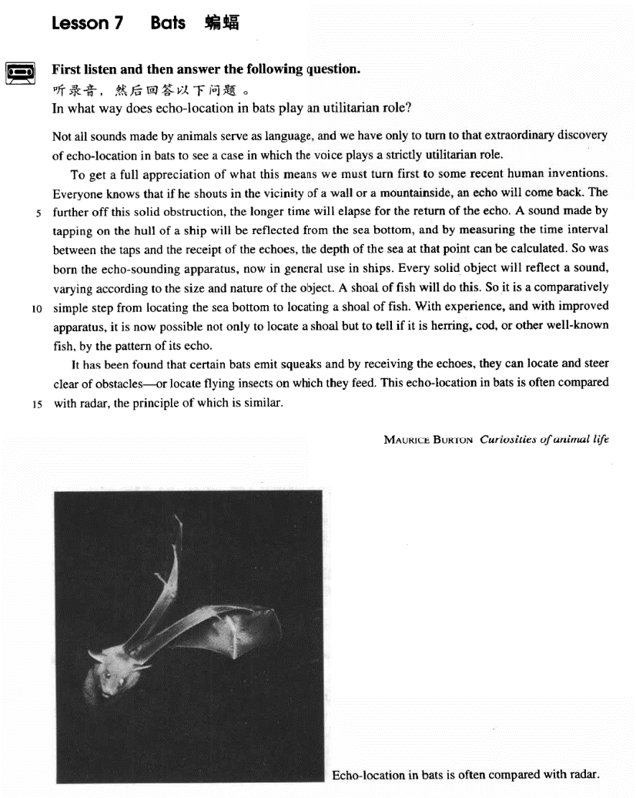

课文

Not all sounds made by animals serve as language, and we have only to turn to that extraordinary discovery of echo-location in bats to see a case in which the voice plays a strictly utilitarian role.

动物发出的声音不都是用作语言交际。我们只要看一看蝙蝠回声定位这一极不寻常的发现，就可以探究一下声音在什么情况下有绝对的实用价值。

To get a full appreciation of what this means we must turn first to some recent human inventions.

要透彻理解这句话的意义，我们应先回顾一下人类最近的几项发明。

Everyone knows that if he shouts in the vicinity of a wall or a mountainside, an echo will come back.

大家都知道，在墙壁或山腰附近发出的喊声，就会听到回声。

The further off this solid obstruction, the longer time will elapse for the return of the echo.

固体障碍物越远。回声返回所用时间就越长。

A sound made by tapping on the hull of a ship will be reflected from the sea bottom, and by measuring the time interval between the taps and the receipt of the echoes the depth of the sea at that point can be calculated.

通过敲击空船发出的声音将会从海底反射回来，测出回声间隔的时间，便可算出该处海洋的深度。

So was born the echo-sounding apparatus, now in general use in ships.

这样就产生了目前各种船舶上普遍应用的回声探测仪。

Every solid object will reflect a sound, varying according to the size and nature of the object.

任何固体者反射声音，反射的声音因物体的大小和性质的不同而不同。

A shoal of fish will do this.

鱼群也反射声音。

So it is a comparatively simple step from locating the sea bottom to locating a shoal of fish.

从测定海深到测定鱼群，这一进展比较容易。

With experience, and with improved apparatus, it is now possible not only to locate a shoal but to tell if it is herring, cod, or other well-known fish, by the pattern of its echo.

根据经验和改进了的仪器，不仅能够确定鱼群的位置，而且可以根据鱼群回声的特点分辨出是鲱鱼、鳕鱼，这是人们所熟悉的其他鱼。

It has been found that certain bats emit squeaks and by receiving the echoes, they can locate and steer clear of obstacles -- or locate flying insects on which they feed.

人们发现，某些蝙蝠能发出尖叫声，并能通过回声来确定并躲开障碍物，或找到它们赖以为生的昆虫。

This echo-location in bats is often compared with radar, the principle of which is similar.

蝙蝠这种回声定位常常可与雷达相比较，其原理是相似的。

词汇讲解

### utilitarian

* **utilitarian** [7ju:tɪlɪ'teəriən] adj. 实用主义的

**utilitarian** adj. **英文解释：**designed to be useful rather than attractive

* ugly **utilitarian** buildings
* **utilitarian** furniture

**【词根】**

utility + “**tarian**”(主义的、主义者)

**vegetarian** n. 素食者；食草动物 adj. 素食的

***﻿*totalitarian** n. 极权主义者；adj. 极权主义的

﻿**humanitarian** n. 人道主义者；adj. 人道主义的；

﻿**egalitarian** n. 平等主义；平等主义者；adj. 平等主义的

### elapse

* **elapse** [ɪ'læps] v. 时间流逝
* Three years **elapsed**.

**【近似词组】**表达“**时间流逝**”：

**go by** / **pass**

* Three years **went by** / **passed**.

**【词根】**

“**lapse**” = slide 滑

**collapse**  倒塌

**relapse** 复发，再发

* **relapse** into bad habits

### interval

* **interval** ['ɪntəvl] n.（两件事之间的）间隔时间

**interval between A and B** A和B的间隔时间

**at … intervals** 每隔一段时间，某事发生

* **at** weekly / 20 minute **intervals**
* The trains run **at** hourly **intervals**.
* Indeed, it may well be that those work is their pleasure are those who most need the means of banishing it **at intervals** from their minds.

### shoal

* **shoal** [ʃəʊl]n. 鱼群
* a **school** / **shoal** of fish 一群鱼

**【扩展】**Lesson04-02 复习

* a **flock of** sheep / pigeons 羊群/鸽群
* a **herd of** cattle / deer / elephants 多指牲畜，牛群
* a **drove of** horses / cattle / sheep 驱赶的动物群
* a **pack of** wolves / tigers / lions 多指猛兽、食肉动物
* a **pride of** lions 专指狮子
* a **swarm of** flies / bees 飞虫
* a **colony of** ants / termites 一群

### squeak

* **squeak** [skwi:k] v. & n. （发出）尖叫声，尖锐的声音
* the **squeak** of a mouse
* The door opened with a **squeak**.

**【近义词组】**表达“发出尖锐的生意”：

**screech**

* the **screech** of tire

**【辨析】**

**scream** / **shriek** （只能指人）尖叫

* The girls are **screaming** / **shrieking** with excitement.

课文讲解

# （标题）

# Bats

课文介绍

**Bats** are interesting animals. They are famous for their echo-location ability（回声定位能力）. Echo-location in bats are often compared with radar.

课文文体：**科技英语的特点**

1、倾向于将动词名词化。（学术文章；庄重、正式）

2、倾向于更多地使用被动语态。（表现出客观，人出现的太多的话，主观因素太强）

# （第一段）

# Not all sounds made by animals serve as language, and we have only to turn to that extraordinary discovery of echo-location in bats to see a case in which the voice plays a strictly utilitarian role.

**语法分析：**

Not all sounds *made by animals（后置定语）* serve as language, and we *have only to（只需要）* turn to that extraordinary discovery of echo-location in bats *to* see a case in which the voice plays a strictly utilitarian role（which...定语从句）.

知识点（1）Lesson03-46、Lesson04-07扩展

**语法：not** 与 **all**, **every**, **everything**, **everyone**, **both** 连用多表示**部分否定**

* **All** that glitters is **not** gold. 闪光的都不是金子
* **Every** machine here is **not** produced in our plant.
* **Both** of the substances do **not** dissolve in water.
* **特殊有歧义的句子：**
* **All** of the arrows **didn’t** hit the target.
* 翻译1（部分否定）：并非所有的箭都没有命中
* 翻译2（全部否定）：所有的箭都没有命中
* **只有全部否定含义：**
* **All** civilized people **can’t** be cannibals.
* 翻译（全部否定）：所有文明人都不吃人肉
* **只有全部否定含义：**
* **Not all** the water in rough rude sea can wash the balm off from an anointed king.
* 翻译（全部否定）：所有汹涌澎湃的沧海之水都洗不掉神圣国王头顶的芬芳
* **避免歧义尽量使用全部否定词：**
* **None** of the arrows hit the target.
* **课文写法替换：**部分否定
* **Not every** sound made by animals serves as language.

知识点（2）Lesson03-25、Lesson03-45

**act as / serve as / function as / be used as …** **（事物做主语）**当做……来使用

* One of the most famous sailing ships of the nineteenth century, the Cutty Sark, can still be seen at Greenwich. She stands on dry land and is visited by thousands of people each year. She **serves as** an impressive reminder of the great ships of past.

知识点（3）

**have only to do … to do …** 只须……就可以……

* You **have only to** press the button **to call** the nurse.
* You **have only to** click the following link **to download** the software.

**have only to turn to sth. to do …** 只需借助于……就可以……

* 造句：我们只需借助于 1936 年奥运会的具体例子就可以知道国际体育比赛会导致疯狂的仇恨。
* We **have only to turn to** the concrete example of the 1936 Olympic Games **to know** that international sporting contests lead to orgies of hatred.

知识点（4）

**strictly** adv. **英文解释：** exactly and completely 完全地

* She is **strictly** a beauty.
* It’s **strictly** a neutral organization.

知识点（5）Lesson03-49

**play / perform / act (the role / part of) …** 扮演……的角色

* He played / performed / acted (the role / part of) Othello.

**play a … role / part in …**（派生含义）发挥某个作用

* The river which forms the eastern boundary of our farm has always **played an important part in** our lives.
* The government should **play a more prominent part in** promoting human rights.
* Not all sounds made by animals serve as language, and we have only to turn to that extraordinary discovery of echo-location in bats to see a case **in** which the voice**plays a strictly utilitarian role**.
* This applies particularly to chemical industries, where chance discoveries **play a much larger part** than they do **in** physical and mechanical industries.
* The fact of first-rate importance is **the predominant role** that custom **plays in** experience and **in** belief, and the very great varieties it may manifest.
* John Dewey has said in all seriousness that **the part played** by custom **in** shaping the behavior of the individual, as against any way in which he can affect traditional custom, is as the proportion of the total vocabulary of his mother tongue against those words of his own baby talk that are taken up into the vernacular of his family.

# （第二段）

# To get a full appreciation of what this means we must turn first to some recent human inventions.

**语法分析:**

To get a full appreciation of *what this means**（what… 宾语从句）*（To… 目的状语）we must turn first to some recent human inventions.

知识点（1）**熟词僻意**

**appreciation** 理解（书面语）

* There is a growing **appreciation** of the need for environmental reforms.
* **阅读真题：熟词僻意**
* There is, I think, much truth in Patricia Nelson Limerick’s **observation**（某人说的话） that “lecturing is an unnatural act, an act for which God did not design human.”
* **考研阅读：**
* With the start of BBC World Service Television, millions of viewers in Asia and America can now watch the Corporation’s news **coverage**（新闻报道）, as well as listen to it.
* Social science **disciplines**（学科） include geography, economics, political science, psychology, and sociology.
* “The test of any democratic society,” he wrote in a *Wall Street Journal* column, “lies not in how well it can control expression but in whether it gives freedom of thought and expression the widest possible **latitude**（自由）, however disputable or irritating the results may sometimes be.”

知识点（2）

**写作**：名词化

* To get a full **appreciation** of what this means…
* … to fully **appreciate** what this means …

知识点（3）

**turn to** 求助于…、借助于…

**【辨析】**

**resort to …**诉诸于…

* We can solve this problem without **resorting to** legal action.

# Everyone knows that if he shouts in the vicinity of a wall or a mountainside, an echo will come back.

**语法分析：**

Everyone knows that *if he shouts in the vicinity of a wall or a mountainside**（if... 条件状语从句）*, an echo will come back. （that… 宾语从句）

知识点（1）Lesson03-06、Lesson03-34

**in the neighbourhood / vicinity of** Piccadilly **在…附近**

**【近义词组】**表达“**在…附近**”：

* a famous arcade **near** Piccadilly
* a famous arcade **close to** Piccadilly
* a famous arcade **around** Piccadilly
* a famous arcade **off** Piccadilly
* a famous arcade **in the neighbourhood / vicinity of** Piccadilly
* **托福听力：**

A. She needs help finding a place to live.

B. There aren't enough rooms available in the dormitories.

C. She can't afford to live on campus.

D. She doesn't want to live in university housing.

* 对话：
* M: Will you be living in the dormitory this year?
* W: Not if I can help it. I've been thinking of renting an apartment **off campus** with some friends of mine.
* Q: What does the woman imply?
* Answer: (D) She doesn't want to live in university housing.

知识点（2）

**【近义词组】**表达“**返回来**”：近义替换、避免重复

**come back**

**bounce back**

**be reflected**

* A sound made by tapping on the hull of a ship will **be reflected** from the sea bottom, …

# The further off this solid obstruction, the longer time will elapse for the return of the echo.

**语法分析：**

The further off this solid obstruction（比较，相当于条件状语从句）, the longer time will elapse for the return of the echo（介词短语当后置定语，修饰主语time）.

知识点（1）

He lives far **away**.

= He lives far **off**（adv）.

知识点（2）

**far**比较级和最高级

**far --> farther**（距离上的）**/ further**（抽象上的）**--> farthest / furthest**

* **further** development / investigation 更深入的调查

知识点（3）

本句话总结：The time and the distance are in proportion. 时间和距离成正比

复习知识点：比较级Lesson03-09、Lesson 03-43、Lesson 03-55

* the further off this solid obstruction **is**（be动词省略） …

**语法**：“**越…越…**”比较

**1）.两个the 分别放在句首，前半句从句，后半句是主句，从前往后翻译**

* The harder they worked(前半句从句，类似条件状语从句) the hungrier they became. （后半句是主句）
* The more he gets, the more he wants
* The harder you work, the greater progress you will（时态：主将从现） make.
* It seems that the further cats fall, the less they are likely to injure themselves.
* **主句倒装**
* The younger the child is （从句）, the more *is* the child’s need of sleep. （主句，倒装）
* The more democracy spreads, the stronger *become*（倒装）the forces of peace.
* **如果谓语动词是be动词，这种句型可省略:**
* The younger the child *is*, the more *is / will be* the child’s need of sleep.
* The younger the child, the more the child’s need of sleep. （be动词省略）
* The higher the standard of living, the greater the amount of paper used. （be动词省略）
* The higher the standard of living *is*, the greater *is / will be*（倒装）the amount of paper used.
* The stronger the magnet, the greater the number of lines of magnetic force. （be动词省略）
* The stronger the magnet *is*, the greater *is* （倒装）the number of lines of magnetic force.
* The greater the percentage of such customers, the weaker the argument’s evidence as an indication of customer satisfaction with the change.
* The greater the percentage of such customers is, the weaker is the argument’s evidence as an indication of customer satisfaction with the change.
* **课文写法替换：**Lesson03-44
* Needless to say, the bigger the risk an insurance company takes, the higher the premium you will have to pay.
* Needless to say, the bigger the risk an insurance company takes *is,* the higher *will be*（倒装）the premium you will have to pay.

**2）.第一句the加比较级放在句中，第二句the加比较级放在句首，只能先翻译后半句，再翻译前半句**

* They became (the) hungrier （前半句是主句）the harder they worked.（后半句是从句）
* I play (the) better（主句）, the more（从句） I practice.
* The more（从句） I practice, the better（主句） I play.
* A compound is considered the more stable（主句）, the smaller（从句） its potential energy.
* We are so familiar with the fact that man ages, that people have for years assumed that the process of losing vigour with time, of becoming more likely to die（主句） the older we get（从句）, was something self-evident, like the cooling of a hot kettle or the wearing-out of a pair of shoes.
* A telescope would have to be as far away as the planet Jupiter to look for life in outer space, because the dust becomes thinner（主句） the further we travel（从句） towards the outer edges of our own solar system.

# A sound made by tapping on the hull of a ship will be reflected from the sea bottom, and by measuring the time interval between the taps and the receipt of the echoes the depth of the sea at that point can be calculated.

**语法分析：**

A sound made by tapping on the hull of a ship（后置定语） will be reflected from the sea bottom, and *by measuring the time interval between the taps and the*

*receipt of the echoes**（between... 后置定语,修饰****interval****）*（*by…* 方式状语）, the depth of the sea at that point can be calculated.

知识点（1）

**【近义词组】**表达“**返回来**”：近义替换、避免重复

**come back**

**bounce back**

**be reflected**

will be reflected

= will come back

= will bounce back

知识点（2）

**【近义词组】**表达“**海床**”：

**sea bottom**

**= sea bed**

**= sea floor**

知识点（3）

* **使用名词更正式:**
* … between the taps and the receipt of the echoes…
* … between the tapping and **receiving** the echoes
* **使用被动,突出客观性:**

**… sb. can calculate sth.**

**sth. can be calculated**

* sound will be reflected depth can be calculated

# So was born the echo-sounding apparatus, now in general use in ships.

知识点（1）

* **正常语序：**
* The echo-sounding apparatus was born **so**.
* **倒装：避免头重脚轻，后置定语连接**
* **So** was born the echo-sounding apparatus, now in general use in ships.

# Every solid object will reflect a sound, varying according to the size and nature of the object.

**语法分析：**

Every solid object will reflect a sound, varying according to（[idiom] 因…而异） the size and nature of the object.

知识点（1）

**vary according to sth.** 因…而异、随…而变化

* 造句：每一个退休工人都可以得到一笔退休金 (pension)，根据职务(post) 和工作年限 (working period) 而有所不同。
* Every retired worker can receive a pension, **varying according to** his post and working period.

# A shoal of fish will do this.

知识点（1）

* **课文补全：**
* A shoal of fish will **reflect a sound, varying according to its size and nature**.

# So it is a comparatively simple step from locating the sea bottom to locating a shoal of fish.

知识点（1）

**comparatively** adv. **relatively** 相对

**It is a *comparatively simple step* from A to B.** 从A到B只有相对比较简单的一小步

**It is a *small step* from A to B.** 从A到B只有一小步

**small step** 一小步

* That’s one ***small step***for a man, one giant leap for mankind. —— Neil Armstrong
* ***It is a small step from*** loving a man ***to*** hating him.
* ***It is a small step from*** loving a man to the bone ***to*** hating him to the core.

# With experience, and with improved apparatus, it is now possible not only to locate a shoal but to tell if it is herring, cod, or other well-known fish, by the pattern of its echo.

**语法分析:**

With experience, and with improved apparatus（方式状语）, it（形式主语）is now possible not only to locate a shoal but to tell if it is herring, cod, or other well-known fish（宾语从句）, *by the pattern of its echo（方式状语）*. （not only to… 真正主语）（but to … 真正主语）

知识点（1）

**写作：**避免出现赘词

**with experience** （固定搭配）随着经验的积累

~~with accumulating experience~~ X 错误搭配（赘词）

**【扩展】**（赘词）

**with time** 随着时间的流逝、逐渐地、慢慢地

* ~~with passing time~~ X 错误搭配（赘词）

**with seasons** 随着季节地更替

* ~~with changing seasons~~ X 错误搭配（赘词）
* the cause of justice（抽象词） 正义事业
* ~~the cause of~~（多余） national reunification（实意词） X 错误搭配（赘词）
* accelerate ~~the speed of~~ economic reform X 错误搭配（赘词）
* The captain knew that his attempt would not be the only attempt. （重复）
* The captain knew that his attempt would not be the only one. （没有简洁多少）
* The captain knew that **his** would not **be the only attempt**. （简洁）
* Our age is a tragic age. （重复）
* Our age is a tragic one. （没有简洁多少）
* **Ours** is **a tragic age**. （简洁）—— Shakespeare

**名家谈写作：Brevity is beauty.** 简洁即是美。

Vigorous writing is concise. A sentence should contain no unnecessary words, a paragraph no unnecessary sentences, for the same reason that a drawing should have no unnecessary lines and a machine no unnecessary parts. —— 斯特伦克 (William Strunk Jr.)

生动有力的写作是简洁的。 一个句子不应有多余的词，一个段落不应有多余的句子，这与绘画不应有多余的线条和机器不应有多余的部件相同。

知识点（2）

to **tell** if it is herring …

* **课文写法替换：**
* … to **distinguish** different species of fish …

知识点（3）

**by** prep. 根据

= **according to …**

* Even **by** modern standards, the 46,000 ton Titanic was a colossal ship.

# （第三段）

# It has been found that certain bats emit squeaks and by receiving the echoes, they can locate and steer clear of obstacles -- or locate flying insects on which they feed.

**语法分析：**

it（形式主语）has been found **that** certain bats emit squeaks and by receiving the echoes（方式状语）, they can locate and steer clear of obstacles—or locate flying insects on which they feed（定语从句）. （**that**...主语从句）

知识点（1）

**emit** v. 放射，发射

**【词根】**

**emit: “e ”(out) + “mit ”(send)**

**submit** “**sub ”(under) + “mit ”**

**transmit**: “**trans ” (across)+ “mit ”**

* sexually **transmitted** diseases
* The US open will be **transmitted** live via satellite.

**vomit**: **“vo ”(eat) + “mit ”**

**omit**: “**o ”=“ob ”(away) + “mit ”**

知识点（2）

**steer clear of …** 躲开

= **avoid …**

= **get around …**

* We tried to **steer clear of** political issues.
* I **steered clear of** the main roads where I might be recognized.

知识点（3）

**feed on sth.** 以…为主食

* Cows **feed on** hay.

prey on sth.（动物，扑食）以…为主食

* Owls **prey on** mice.

live on sth. （人）以…为主食

# This echo-location in bats is often compared with radar, the principle of which is similar.

**语法分析：**

This echo-location in bats is often compared with radar, the principle of which is similar（定语从句）.

知识点（1）

**compare A with / to B A与B**对比；既可以强调AB的相似之处，也可强调AB的区别

**contrast A with B A与B**对比；强调AB的明显不同

知识点（2）Lesson03-32 定语从句

**语法：**“名词 + 介词 + 关系代词” 引导**非限定性定语从句**；前提是定语从句修饰的不是先行词本身，而是先行词相关的东西或一部分

* **造句**：他有两个儿子，其中的一个死于战火。
* He has two sons, **one of whom** died in the war.
* **造句**：演讲者提了 (pose) 四个问题，它们的答案被证明非常具有启发性(illuminating)。
* The speaker posed four questions, **the answers to which** proved very illuminating.
* She hurried home to feed her cats, **one of which** had just had kittens.
* The most valuable find of all was the ship's log book, **parts of which** it was still possible to read.